Squash Capstone – Install / User guide

Main programs used are

1. Django
2. Mysql , https://dev.mysql.com/downloads/installer/
3. Python 3.5 or 3.6, <https://www.python.org/downloads/release/python-367/>
4. opencv

Contents

Python and pip installation. 2

Install MySql 2

Running the Project 5

Using the program 6

Using the squash tracking app 8

## Python and pip installation.

Install python along with pip

https://www.python.org/downloads/release/python-367/

Then open windows power shell as admin and run the following commands

* pip install django=2.0.2
* pip install django-extensions
* pip install opencv-python==3.4.2.17
* pip install keyboard
* pip install numpy
* pip install mysqlclient==1.3.13
* pip install django-import-export

## Install MySql

if the ‘mysqlclient’ install throws an error you will have to download a .whl file from here:

<https://www.lfd.uci.edu/~gohlke/pythonlibs/?fbclid=IwAR1ElEsbb_3A1ZfiK1mgQL7DRCSO2rlphCAehSX3JDHHxBQGmegF9hj_i2M#mysql-python>

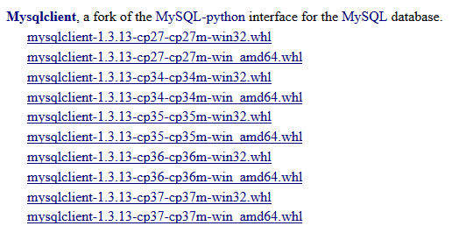

Get the mysqlclient the corresponds to your version of windows and python. Then navigate to the folder you’ve stored it in open up power shell as admin and run the command:

* pip install mysqlclient-1.3.13-cpXX-cpXXm-winXX.whl

where the XX is your version numbers

Next is to install Mysql workbench, mysql server and connectorPython with the Mysql installer using all default settings

Assuming everything is installed correctly you should be able to now run mysql workbench and have a local instance of MySQL

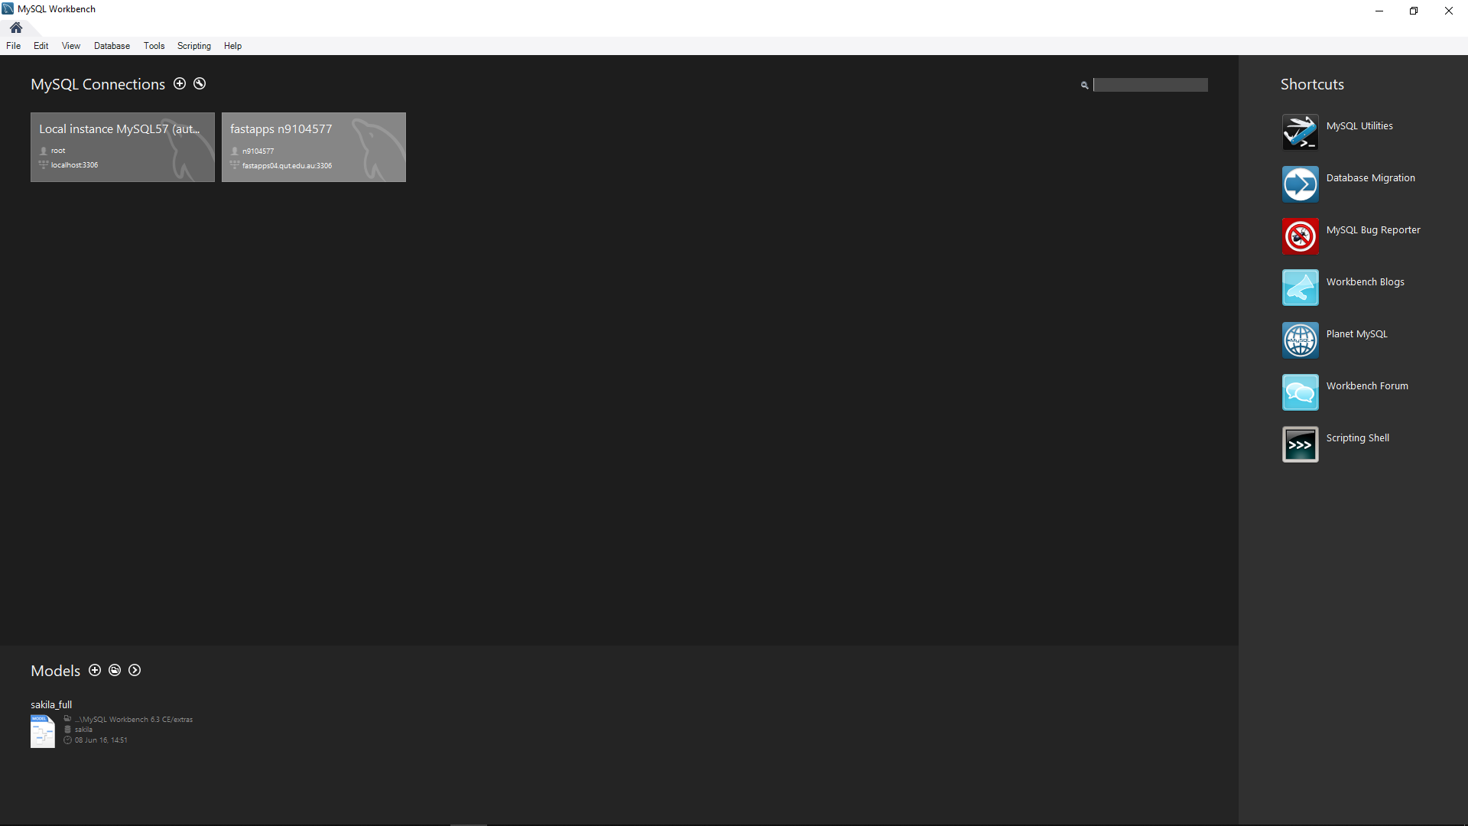

For the following the naming of the database, users and passwords is important as these are all in the settings for the Django application. Any misspellings could result in no connection to the database or throwing errors.

Click on this local instance and select ‘create a new schema’ and call it ‘squashdb’ with a collation of utf8-default

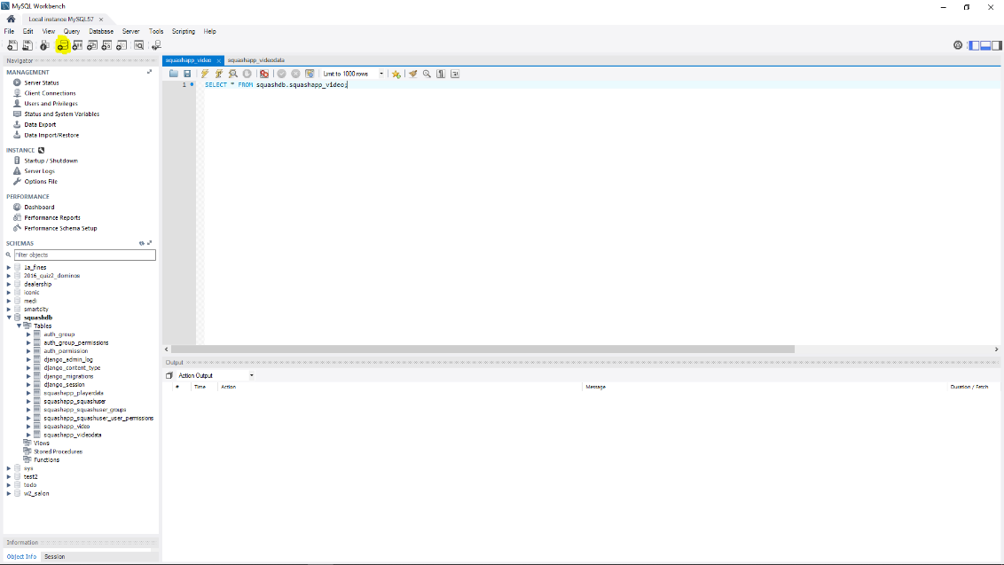

Next click ‘users and privileges’

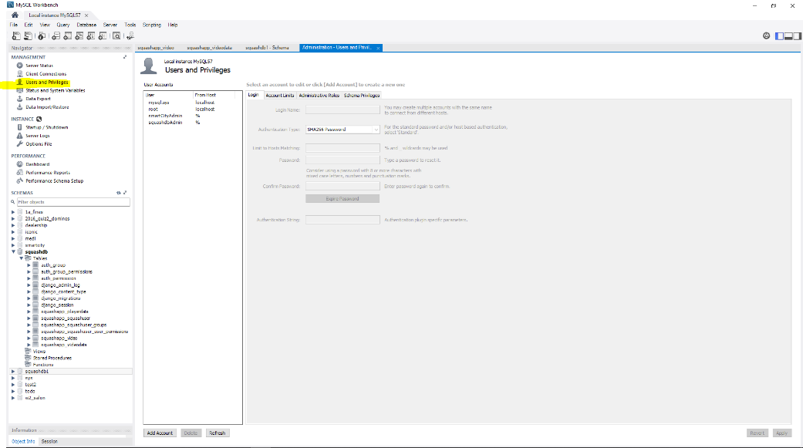

Then click ‘add account’

Name: squashdbAdmin

Password: 5quash

Leave everything else the same and hit apply

Navigate to the ‘schema privileges’ tab making sure you have the squashdbAdmin user selected and then select ‘add entry’

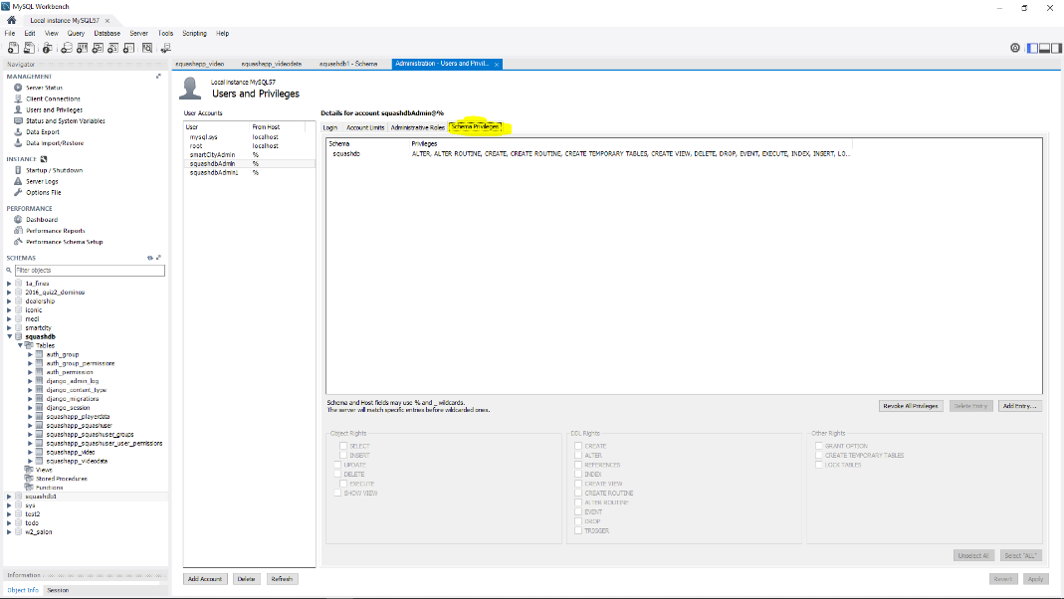

Click on ‘selected schema’ and choose the squashdb from the list, hit ‘ok’, then press the ‘select ‘ALL’’ button and hit ‘apply’

The Database should now be setup and ready to use.

## Running the Project

On first run navigate to where you’ve stored the project files. From the main squash folder navigate to

‘/squashApp/migrations’ and delete everything in the folder except the ‘ __init__.py’ and the ‘__pycache__’ file/folder. This only has to be done the first time everything is installed.

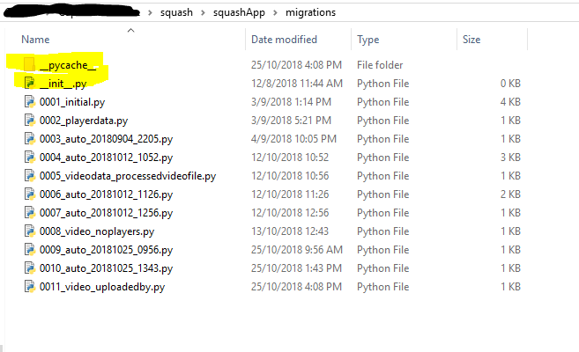

Now navigate back to the main squash directory where the ‘manage.py’ file is and run windows power shell as admin.

Now run the following commands

* python manage.py makemigrations
* python manage.py migrate
* python manage.py createsuperuser follow the prompts
* python manage.py runserver

the first command checks that any updates in the models.py file need to be applied to the database

the second applies these updates to the database

the first and second command must be run whenever ‘models.py’ or ‘settings.py’ is updated.

the third creates a super user which you can user to login and gain access to the database from the site.

and the fourth runs the server. You should now be able to copy the provided ip address into a web browser and start using the website.

The layout of the project is broken down inbetween folders.

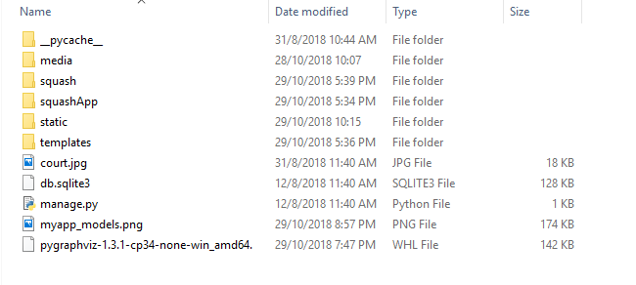

The ‘media’ folder holds all the processed videos/images and the uploaded videos for the website

The ‘squash’ folder has all the settings for the website. The two important files in here are ‘settings.py and ‘urls.py’

The ‘squashApp’ folder is the most used one. This has all the files that you would edit including the ‘SquashTracking.py’ which is responsible for the tracking functionality. For a better understanding on the other files in this folder reading a Django tutorial or documentation would be helpful.

The ‘static’ folder is where the css is stored and the ‘templates’ folder has all the html files.

## Using the program

When using run server the following should be outputted

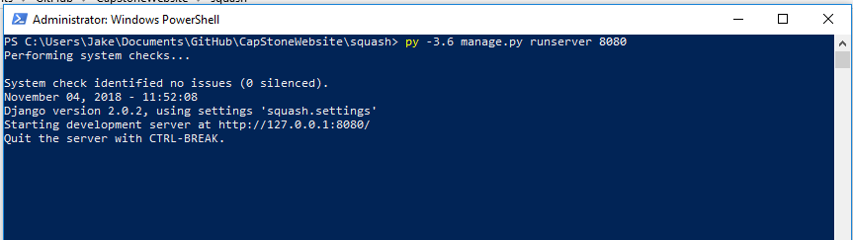

You can now navigate to the ip address givin.

Click login on the main page and login with the super user you created. Click the admin site tab and you will be navigated to the Django admin page.

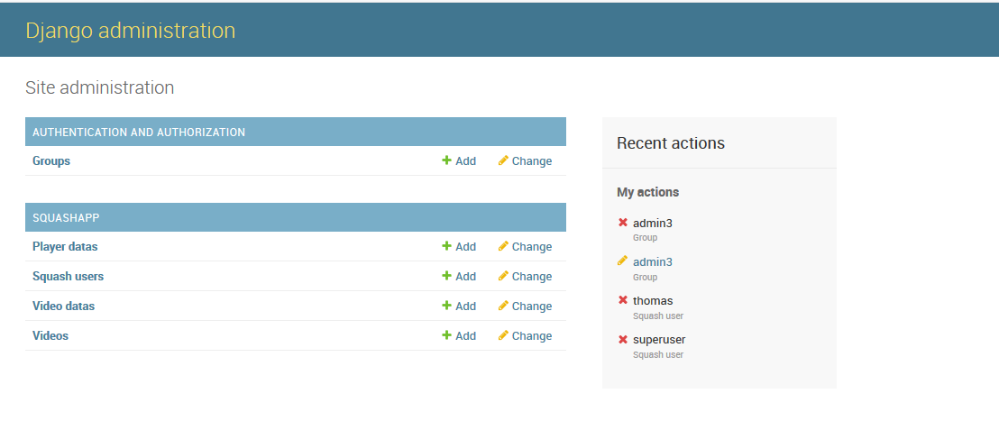

When uploading a video a user must be able to select a squash player that is registered in the database. To add these players simply click the player datas table and then ‘add player data’.

Back on the main site:

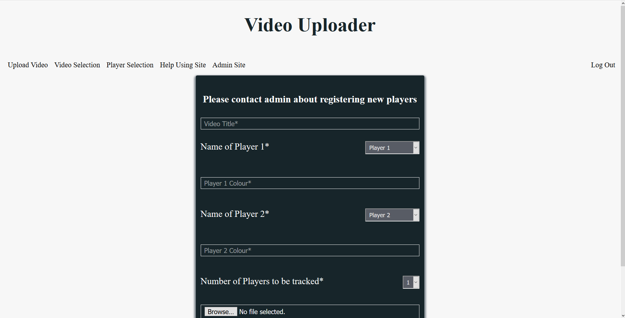

* upload video – this is where a user can upload a video to be tracked. When the hit the upload button a python window will pop up allowing you to use the tracker (see section below).
* Video selection allows a user to view uploaded videos. Currently coach user can see all videos and player users can only see their own upload videos. User types and privileges can be changed by going to the admin site and editing the squash users table.
* The player selection is for coaches only. This lets them click a registered player and view all their videos.
* Help using site gives a guide like the one below on using the tracker
* Admin site is for admin only, allowing them to access the database.

## Using the squash tracking app

